Name: ______________________________________________ Period: _________________
Quadratics Graphing Review
Use a table of values to graph each function. State the domain and the range.
1. y = $x^{2}$ – 4 2. y = –$x^{2}$ + 3 3. y = $x^{2}$ – 2x – 6
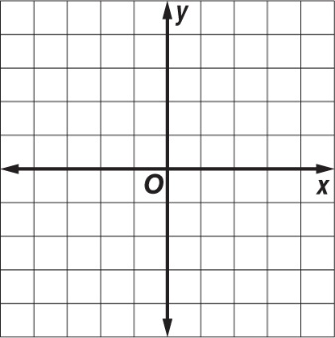
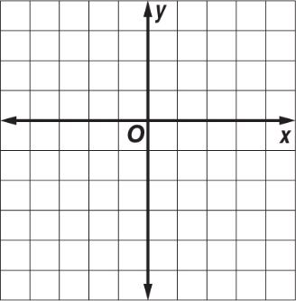
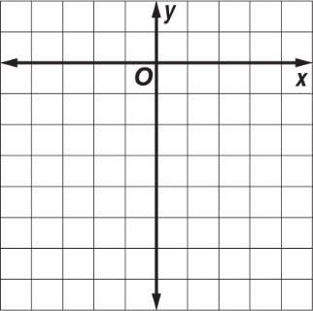

Find the vertex, the axis of symmetry, and the y–intercept of the graph of each function.
4. y = 2$x^{2}$ – 8x + 6 5. y = $x^{2}$ + 4x + 6 6. y = –3$x^{2}$ – 12x + 3

Use a table of values to graph each function. State the domain and the range in interval notation and the maximum or minimum point.

In 9-15, check the transformations that have occurred in each function.
In the following problems, write an equation that shows the appropriate transformations from the description.
Write the new equations below:
Write the equation for the parabola in vertex form.
20. $y=x^{2}+6x-8$ 21. $y=-3x^{2}-6x+7$

Write in standard form.
- $y=(x+3)^{2}-2$ 23. $y=(4x+1)(2x-3)$

Convert to vertex form algebraically and then check graphically.
- $y=(x-2)(x+6)$ 25. $y=3x^{2}+4x-3$

