Name__________________

Date__________________

Review for Comparing Functions

For # 1-4 compare the functions below and fill in the table accordingly

Function 1: y = -3x - 4 Function 2: 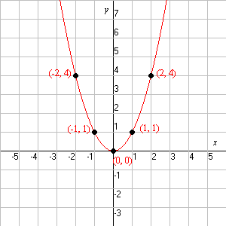

Fill in the table below after analyzing the functions above:

|  |  |  |
| --- | --- | --- |
| Function 1 | Fill in with <, > , or = | Function 2 |
| y coordinate of the y intercept | 1. | y coordinate of the y intercept |
| a(-9) | 2. | b(-7) |
| The rate of change over the interval [-1, 0] | 3. | The rate of change over the interval [-1, 0] |
| The value of x when a(x)= -7 | 4. | The value of x when b(x)= 0 |

For numbers 5- 7 label the functions below as even, odd or nether:

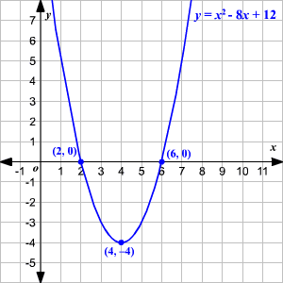 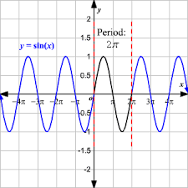 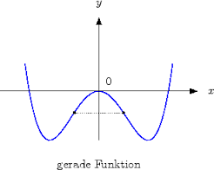

For numbers 8-10. Show algebraically whether the functions are odd, even, or nether.

8. f(x)= 9x -4

9. f(x) = -x2 + 4

10. f(x) = -x3 -4

For numbers 11-13 tell whether the data is continuous or discrete:

11. The number of students in our school ________________

12. Number of pages in a book _________________

13. The length of your hair _________________

Solve the exponential equations for numbers 14-16.

14. 33= 3x+4

15. 82x = 2x+1

16. (1/9) 2 = 3x

Macintosh HD:Users:Drobbins:Documents:MFAS:Tasks and Rubrics:Geogebra Graphs:expontial graph.pdf17. A mother and daughter decided to register for a social media group. The number of messages received by the mother on day *n* is given by the equation *M* = 4*n*. The graph shows the number of messages received by the daughter on day *n* (where *n* is the number of days since joining the group).

Explain the difference in the rates of change in the number of messages the mother receives and the number of messages the daughter receives.

Whose number of daily messages is increasing more rapidly? Justify your answer

Number of Messages

A company offers a bonus retirement plans for its executive employees. The employees are presented with 2 options.

Option #1: They will start an account $5000 and each year earn 25% on the money in the account. (i.e. a growth factor of 1.25)



Option #2: They will start an account $5000 and each year there after continue to add $5000 to the account.



Which retirement option would be worth more at the end of 20 years?

a. Option #1

b. Option #2

c. They are both equal at 20 years.