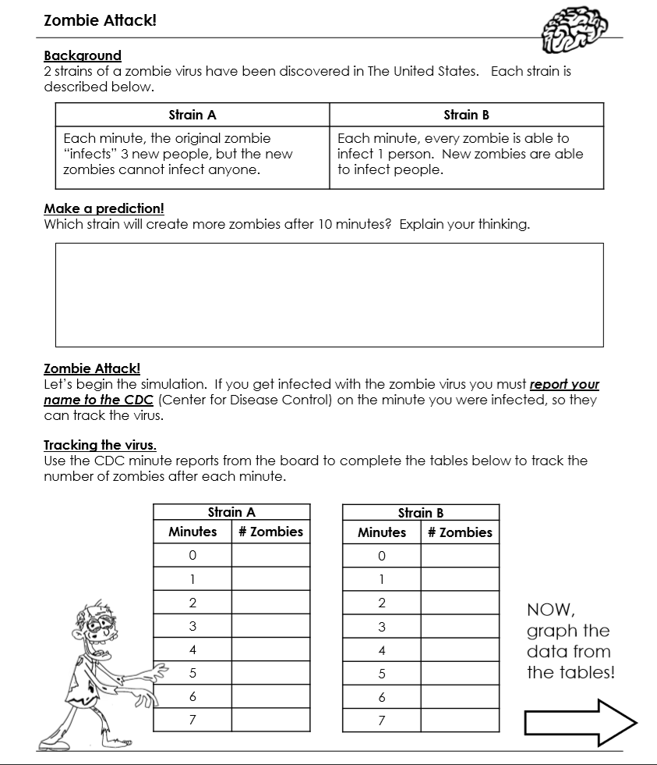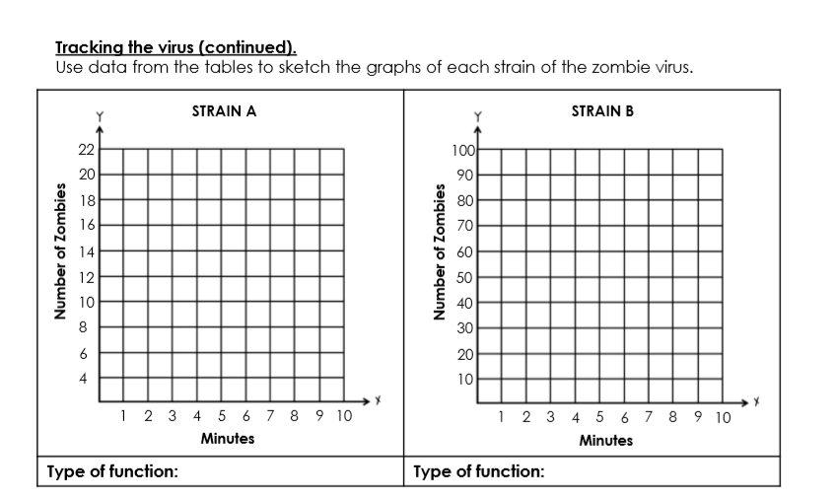
Extension:
What if a zombie entered the Mercedes-Benz Stadium in Atlanta, GA? The capacity of the stadium is 71,000 people.
Estimate how many minutes it will take for the whole stadium to be infected IF…
The original strain A zombie walks into the stadium. ____________________
One strain B zombie walks into the stadium. ____________________
Now, determine how many minutes it will take for the whole Mercedes-Benz Stadium to be infected IF…

Strain A zombie walks into the stadium | Strain B walks into the stadium
